HISTORY OF MULTI-CYCLONE DUST COLLECTOR

In 1878 the seven-story Washburn A Mill in Wisconsin, the largest mill in the world at the time, suffered just such an explosion. It was so massive that it was actually heard 10 miles away and killed 18 workers — not to mention reducing the mill and several neighbouring factories to cinders.

Consequentially, by the 20s the separators were being used on a larger scale than ever before, including in oil refineries where they separated oils and gases, or in sewage treatment plants where adapted ‘hydroclones’ removed solid waste from liquids.

But in the past 25 years the cyclone has arguably become a much larger part of people’s everyday lives simply by getting smaller.

Cyclonic separators were shrunk enough to be used in household appliances for the first time with Sir James Dyson’s invention of the bag-less vacuum cleaner. The idea of putting a cyclone in a vacuum cleaner came after he saw an industrial sawmill at the Bath branch of timber importers, Hill Leigh Ltd. Although this company was liquidated in August 2012, it was bought by Travis Perkins Builders Merchants who still maintain a working sawmill on the site to this day. sawmill on the site to this day. 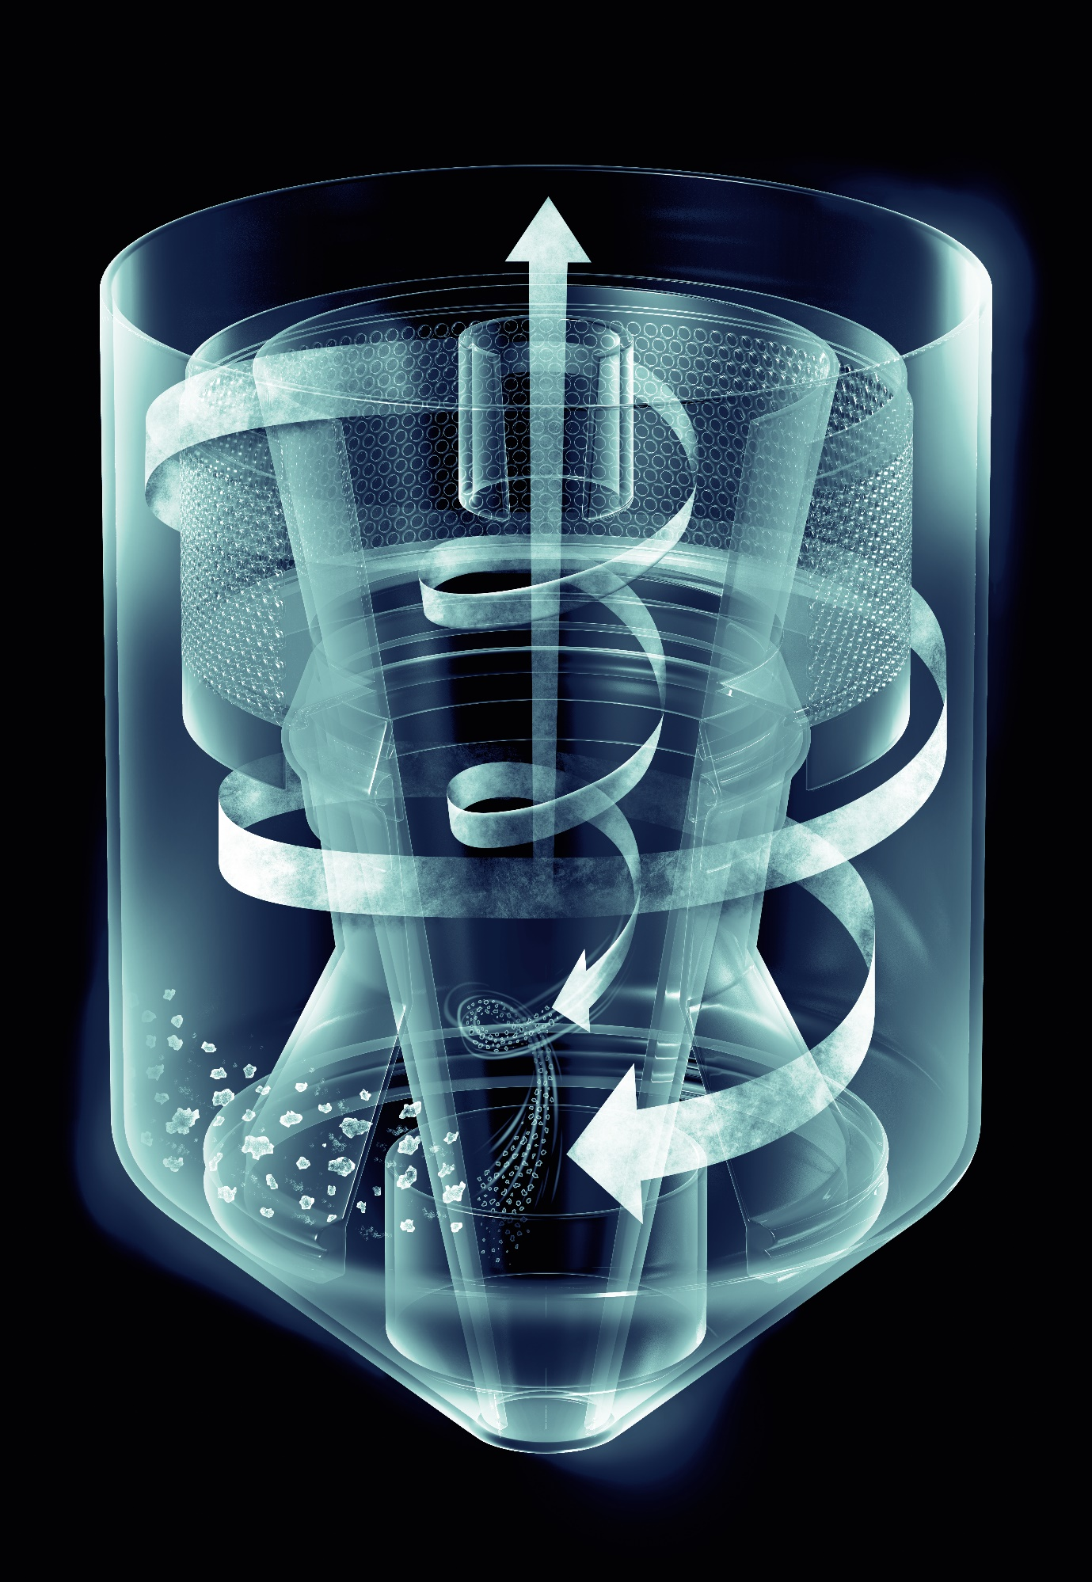

The very first '**cyclonic separator**' was patented in 1885 by the American John M. Finch, for use as a '**dust collector**' in his Knickerbocker Company.” In 1878 the seven-story Washburn a Mill in Wisconsin, the largest mill in the world at the time, suffered just such an explosion.

Sir james said “one day I was at a local sawmill and noticed how the sawdust was being removed from the air by large industrial cyclones. My engineering instinct kicked in. Could that work on a smaller scale? So, I created a cardboard prototype and strapped it on to my machine. It didn’t look great, but it picked up more dust.”

During the 1900s, this technology found wide industrial appeal by offering large scale separation in factories or mills. Another American inventor, O. M. Morse, was awarded a similar patent in 1905 for a new “dust collector” which he developed to reduce “dust explosions” in flourmills. Despite their delicate sounding names these explosions are anything but. They essentially rapidly ignite all the untrapped particles, turning the air itself into a fireball.

At present industries in India are growing rapidly. However, this situation not only gain the economy but also created problems from production processes that might affect environment and human health. Especially the processes in which dust or micro particulates/pollutants are emitted to atmosphere. In coal fired boilers the flue gases have certain particles of solid matter in suspension, this is called smoke or dust. In case of pulverized coal furnaces, the fly ash remains in suspension with flue gases. If the particle in suspension are of size ranging from 1-100 𝜇m, it is called dust or smoke and for particle size more than 100 𝜇m, it is called cinder. Any dust particles leaving into chimney exhaust are objectionable and harmful for the health of human being and for plant life. The production of smoke in chimney exhaust is also indicative of incomplete and improper combustion of fuel, in turn, it is indicative of low thermal efficiency of the thermal power plant. Nowadays rules and regulations regarding emissions and pollution control are getting strict. Therefore, it is always necessary to clean the gas from dust, smoke, or cinder particles before it is to be discharged from the chimney. Therefore, to reduce the emission from steam producing industries we are willing to design and manufacture a multicyclone dust collector. Keywords: - Cinder, Contaminants, Electrostatics, Fly-ash, Multicyclone, Particulates, Pulverized

The products of combustion of coal-fed fires contain particles of solid matter floating in suspension. This may be smoke or dust. If smoke, the indication is that combustion conditions are faulty, and the proper remedy is in the design and management of the furnace. If dust, the particle are finally fine ash particles called “Fly-ash” intermixed with some quantity of carbon-ash material called “Cinder”. Pulverized coal and spreader stoker firing units are the principle types causing difficulty from this source. Other stokers may produce minor quantities of dust but generally not enough to demand special gas cleaning equipment. The two mentioned are troublesome because coal is burned in suspension-in a turbulent furnace atmosphere and every opportunity is offered for the gas to pick up the smaller particles and sweep them along with it. The size of the dust particles is measured in microns. The micron is one millionth of a meter. As an indication of the scale of this measure, the diameter of the human air is approximately 80 microns.

Multi cyclone dust collectors are used in many processes to either recover valuable granular solid or powder from process streams, or to remove granular solid pollutants from exhaust gases prior to venting to the atmosphere. Dust collectors may be of single unit construction, or a collection of devices used to separate particulate matter from the process air. They are often used as an air pollution control device to maintain or improve air quality.

A multicyclone dust collector is a system used to enhance the quality of air released from industrial and commercial processes by collecting dust particles and other impurities from air or any gas. Designed to handle high-volume dust loads, a dust collector system consists of a blower(dryer), dust filter, a filter-cleaning system, and a dust receptacle or dust removal system. It is distinguished from air purifiers which use disposable filters to remove dust.

Fume and smoke collectors are used to remove sub-micro-size particulates from the air. They effectively reduce or eliminate particulate matter and gas streams from many industrial processes such as from welding industries, rubber industries and plastic processing industries, high speed machining with coolants , tempering.